Quarterly Construction Report Q3 2026
Harrow Bay Offshore Wind · for Hanseatic Infrastructure Bank and the lender group
Marcus Bell · 02 October 2026 · HB-FIN-LR-2026-Q3
DRAFT – for review by Elena Márquez and Jonas Richter before submission on 15 October.

1. Executive summary
By 30 September 2026, 13 of 40 monopiles were installed (HB-A14 completed on 30 September, reported after period end), against 16 in the baseline. The offshore substation topside was installed on 19 August. The Steering Committee approved a recovery plan on 23 September (charter option 2, 24/7 piling). Forecast for the last monopile is 26 February 2027; first power remains 30 September 2027.

2. Construction progress
Workstream | Status
Foundations | 13/40 monopiles installed
Offshore substation | Topside installed 19 Aug
Export cables | Cable 2 delayed – delivery 12 Mar 2027
Turbines | Manufacturing started in Aarhus
Onshore substation | Civil works 62 %, transformers ordered

3. Cost and financing
Actual spend to 30 September 2026: EUR 789.9 m (48.8 % of EAC). EAC remains EUR 1,620 m; contingency remaining EUR 31.4 m. Potential recovery of liquidated damages from Severn Subsea Cables (est. EUR 4.2 m) is not included.
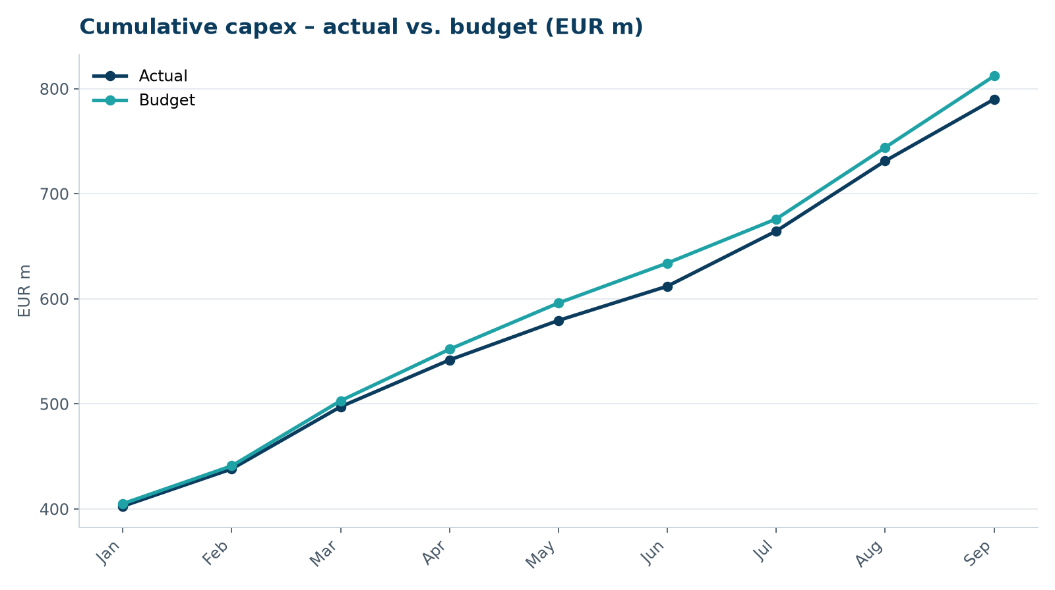
Capex development
Drawdown | Date | Amount (EUR m)
DR-06 | 15 Jul 2026 | 48.1
DR-07 | 17 Aug 2026 | 62.9
DR-08 | 15 Sep 2026 | 57.3

4. Key risks
ID | Risk | Rating | Mitigation
HB-RISK-017 | Export cable 2 delay (Severn) | High | Resequenced cable lay; LDs under WE-CON-2025-031
HB-RISK-029 | Monopile campaign into winter | High | Charter option 2, 24/7 piling
HB-RISK-030 | Turbine installation start | High | Install string A first

5. HSE and environment
Zero lost time injuries. Noise monitoring: one exceedance at HB-A04 (April), all other piles compliant. Marine mammal and seabird monitoring by Marlow Ecology in line with consent conditions.

6. Compliance with finance documents
No event of default. All information undertakings met. The Lenders' Technical Adviser visited the Port of Eastholm and MV Sea Atlas on 8 September 2026 and confirmed the recovery plan as reasonable.

